Taking Shape and Gaining Ground
Horses belong to a species known as equines. While all horses are equines, not every equine is a horse. In addition to horses, equines can be ponies, donkeys, mules, and zebras. Size, shape, and structure can determine what type of equine an animal is and what it would be best suited for. Over time, people have selected specific characteristics in equines such as height, weight, and speed to create different breeds for different purposes. As a result, equines come in all shapes and sizes. Let’s take a look at horses and see how they measure up.
- Measuring Horse Height

All equines are measured in “hands”. A hand equals 4 inches. To determine how many hands a horse is, its height is measured from the ground to the withers (Figure 1).
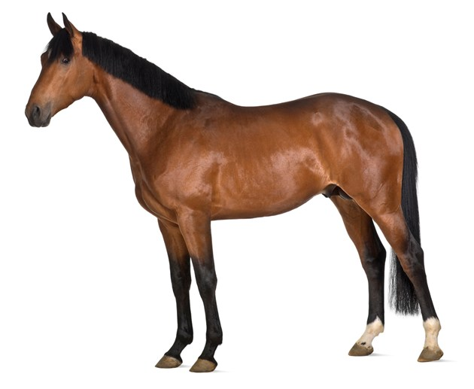
Figure 1. Measuring a horse.
Withers

Activity

Using the examples below, measure the following horses and determine how tall they are in hands or inches.

This Quarter Horse is 15.2 hands tall. How many inches would that be?
1 hand = 4 inches
For every 1/10 (0.1, 0.2, 0.3) you add an inch up to 0.4 which would be equal to another hand in height.
Answer:
15 x 4 = 60 inches
60 inches + 2 inches = 62 inches

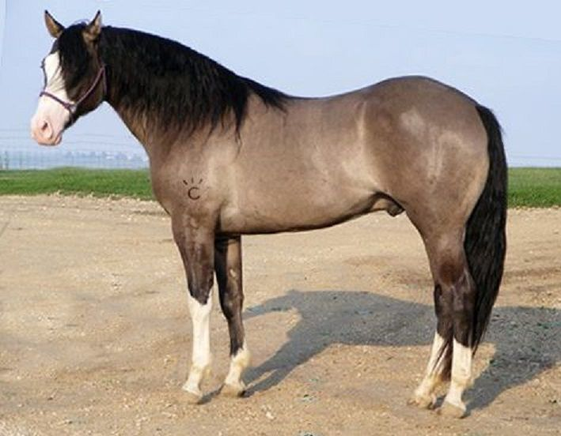

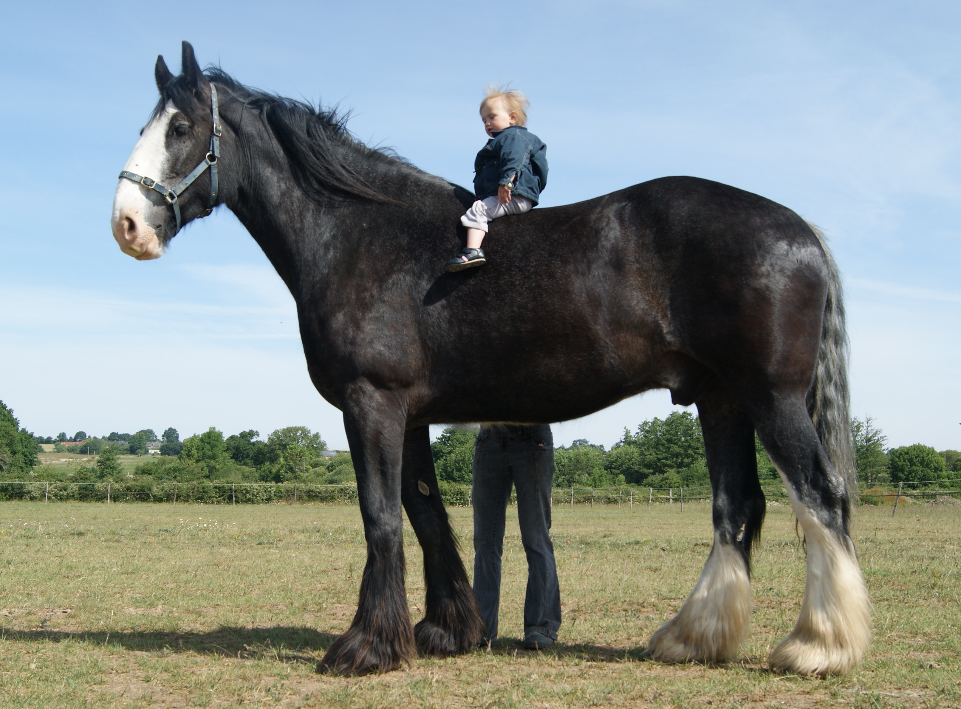
This Shire Horse is 68 inches tall. How many hands would that be?
1 hand = 4 inches
For every 1/10 (0.1, 0.2, 0.3) you add an inch up to 0.4 which would be equal to another hand in height.
Answer:
68 ÷ 4 = 17 hands

How Tall Are These Equines?
Show your work.
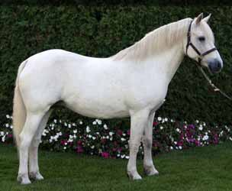
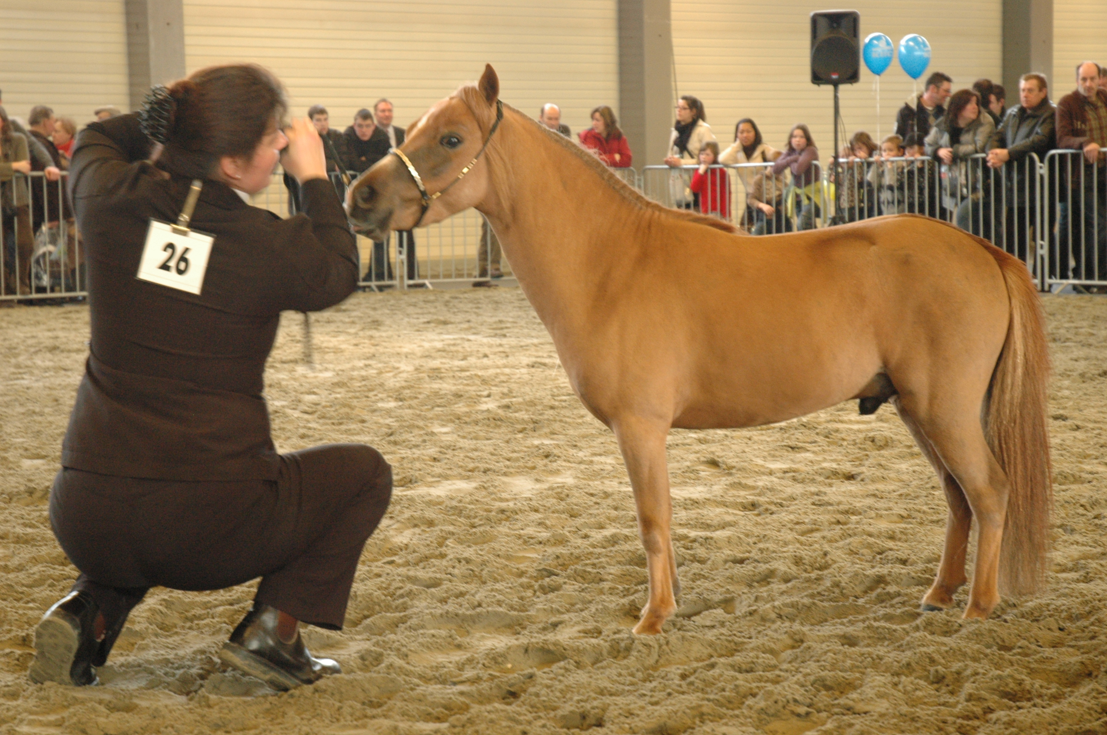

This Miniature Horse is 32 inches tall. This Connemara Pony is 13 hands tall.
How many hands is that? How many inches is that?

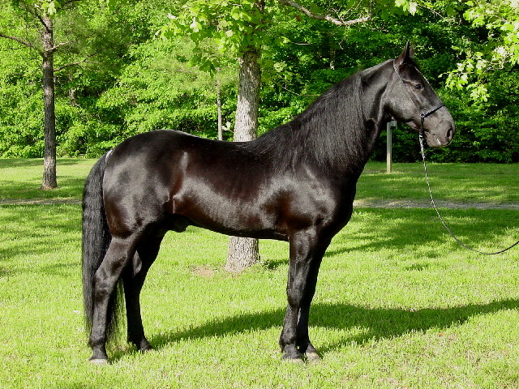
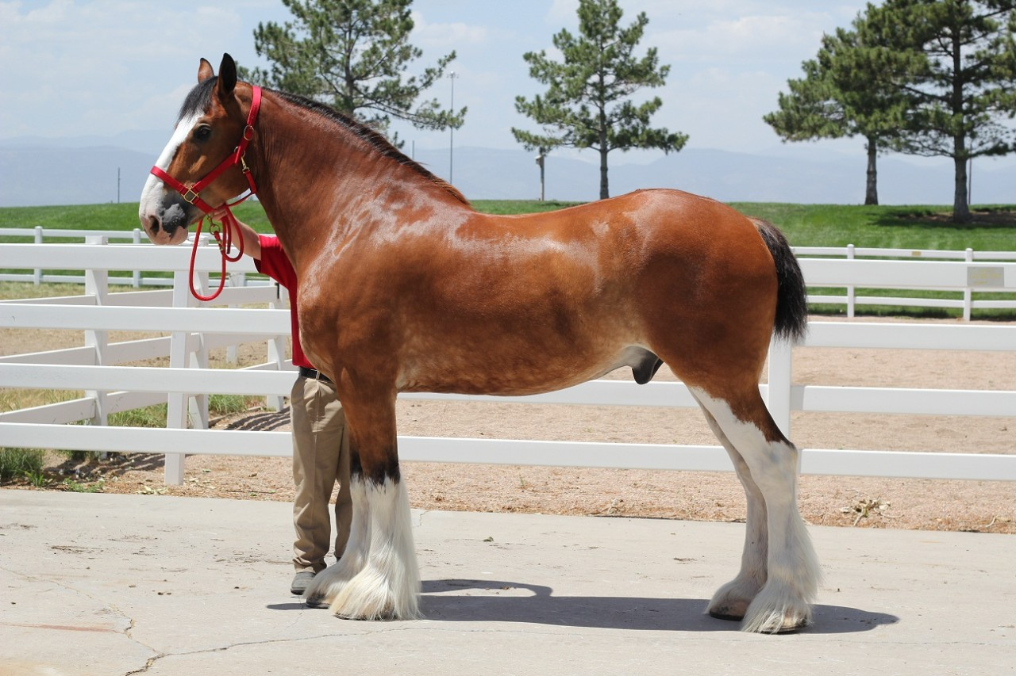

This Tennessee Walking Horse is 64 inches tall. This Clydesdale is 18 hands tall.
How many hands is that? How many inches is that?

- Measuring Horse Weight

In the United States, horses are measured in pounds using a scale. Some horses are so large they can weigh more than one ton.

Activity 1

Grades K-4: Weigh a group of kids and determine how many of them it would take to equal the average weights of the following horses in pounds.

  - Miniature Horse: 200 pounds

  - Thoroughbred (Race Horse): 1,000 pounds

  - Shire (Draft Horse): 2,000 pounds

Activity 2

Grades 5-8: Using the example below, determine how much each of these horses weigh in tons, kilograms, or stones. Show your work.

Example:
Ranger, a Quarter Horse weighs 1,000 pounds.
- How much does he weigh in tons?
1 ton = 2,000 pounds

Answer:

2,000 ÷ 1,000 = 1,000 or ½ ton

- How much does he weigh in kilograms?
1 kilogram = 2.2 pounds

Answer:

1,000 ÷ 2.2 = 454.54 kilograms

- How much does he weigh in stones?
1 stone = 14 pounds

Answer:

1,000 ÷ 14 = 71.4 stones

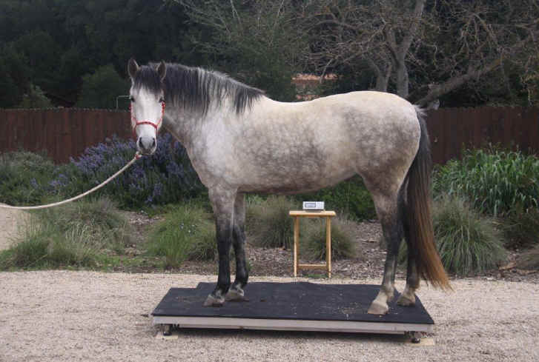
Figure 2. Weighing a horse.

- A Falabella miniature horse weighs 50 pounds. How much does he weigh in kilograms?

- A Shetland Pony weighs 600 pounds. How much does she weigh in stones?

- A Thoroughbred weighs 900 pounds. How much does he weigh in tons?

- A Shire weighs 2,200 pounds. How much does she weigh in tons?

Did You Know?
A Shetland Pony can pull twice its own weight but a Shire Horse can only pull half its own weight?

- Measuring Distance

Horses have different ways of moving forward called gaits. A gait can be a walk (slow), trot, canter, or gallop (fast). Each gait requires that every foot hit the ground at least once to form a stride. So, the distance between the point where one hoof makes contact with the ground and the point where that same hoof next makes contact with the ground is stride length. Stride length becomes longer the faster a horse travels. Stride length is also dependent on the size of the horse. Just like in people, short horses have short strides and tall horses have long strides. The average stride length of a thoroughbred is 24.6 feet (Source: Equix). Man o’ War, a famous thoroughbred race horse, had an average stride length at full gallop of 28 feet.

The distance between horses in a horse race is called a length. One length is the measurement of a horse from nose to tail and equals 8 feet. Secretariat won the 1973 Belmont Stakes by 31 lengths (248 feet) and swept the Triple Crown (Kentucky Derby, Preakness and Belmont) that year.

1 horse length = 8 feet

The distance a horse travels is measured in feet. In a horse race, this distance is converted to and reported as furlongs. One furlong equals 0.125 miles or 660 feet. There are 8 furlongs in a mile or 5,280 feet.

1 furlong = 0.125 mile
8 furlongs = 1 mile
1 mile = 5,280 feet

Activity 1

Grades K-3:
- Teach students the difference between step length and stride length (See Figure 3). Lay out Man O’ Wars stride (28 feet). Have kids walk it to determine the number of steps and paces it takes them to complete the distance. Discuss the differences between students.

- Have students lay down head to toe to see how many students it takes to equal one of Man O’ War’s strides.

- Have students line up and take one step or one pace. Discuss the differences between students.

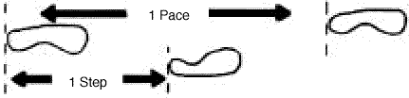
Figure 3. The human stride.

Activity 2

Grades 3-5: How many furlongs in this race?

Activity 2

Grades 3

- In 2015, American Pharoah won the Kentucky Derby race by 1 length. How many feet is that? Show your work.

- American Pharaoh also won the Preakness Stakes race by 7 lengths. How many feet is that? Show your work.

Activity 3

Grades 5-8:

- The Kentucky Derby race is 1 ¼ miles (1.25). How many strides did it take Man O’ War to reach the end of this race? Assume Man O’ War’s stride is the average length of 28 feet for the entire race. Show your work.

- The Belmont Stakes race is 1 ½ miles long. How many furlongs is this race?

- Other Good Sources of Information:

Horse Lovers Math – www.horseloversmath.com
Thoroughbred Greats – www.tbgreats.com

ANSWERS

- Measuring Horse Height
- Miniature Horse
32 ÷ 4 = 8 hands tall

- Connemara Pony
13 x 4 = 52 inches tall

- Tennessee Walking Horse
64 ÷ 4 = 16 hands tall

- Clydesdale
18 x 4 = 72 inches tall

- Measuring Horse Weight
- 50 pounds ÷ 2.2 kilograms = 22.72 kilograms
- 600 pounds ÷ 14 stones = 42.86 stones
- 900 pounds ÷ 2,000 = 0.45 tons
- 2,200 pounds ÷ 2,000 = 1.1 tons

- Measuring Distance
Activity 2
- 1 length x 8 feet = 8 feet
- 7 lengths x 8 feet = 56 feet
Activity 3
- 1 mile = 5,280 feet
Length of the Kentucky Derby = 1.25 miles or 1.25 x 5,280 = 6,600 feet
Man O’ War’s Stride Length = 28 feet

6,600 feet (length of the Kentucky Derby) ÷ 28 feet (length of Man O’ War’s Stride) = 235.71 strides

- 1 mile = 8 furlongs
1.5 miles x 8 furlongs = 12 furlongs in the Belmont Stakes

Developed by Georgette Plaugher, Georgy.Plaugher@ mail.wvu.edu

